Programme and Report
STESSIE
Strengthening, spreading (disseminating, implementing and evaluating)
the Toolbox for (self-)Evaluation and Stimulation
Social Inclusion in Education

Cooperation partnership in school education – Erasmus+ project KA220

October 14th – 18th 2024
Hotel Moskva, Belgrade, Serbia

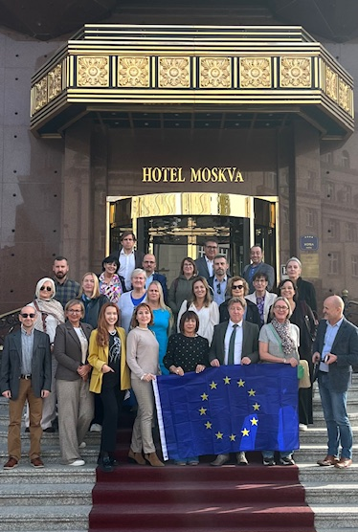
Attendances |  | Branislav Randelović  Elizabeta Karalić  Danijela Đukić  Jelena Nedeljković  Katarina Glišić  Jovana Lukić  Aleksandar Stanisavljević  Dragan Stanojević  Tanja Ranković  Snežana Vuković  Ana María Esteve López  María Saturnina Rueda Egido  Alexander Cutajar  Erik De Bou  Els Van Raemdonck  David Vromant  Silke Daelman  Xabier Elosegui  Rosa Aliaga Ugarte  Wilma Brings  Joa Baum  Francisco José Quiroga Fernández  Paula Serra Gómez  Christopher Kenely  Vesela Politova  Tsvetelina Rashkova  Malina Edreva  Kaidi Maask  Ruth Elias  Agnes Bessac  Aitziber Ortuondo de la Brena  Francisco Antonio Cabanillas Peromingo  Sylvain Begue
 | Reporters | Elizabeta Karalić

PROGRAMME

Monday October 14th, 2024

19.00-20.00 | Informal meet and greet with the hosts Branislav Ranđelović, Elizabeta Karalić, and Danijela Đukić

Tuesday October 15th, 2024
(Meeting room Moskva at the Hotel Moskva)

09.30 – 10.00 | Welcome and registration at the Hotel Moskva
10.00 – 11.00 | Introduction and welcome – PhD Branislav Ranđelović, Director of the IEQE  Weekly Activities Overview, Objectives, and Useful Information – PhD Elizabeta Karalić,  Danijela Đukić (Moderator)
11.00 – 12.00 | Social and Gender Inequalities – PhD Dragan Stanojević, Department of Sociology, Faculty of Philosophy, University of Belgrade (TBC)
12.00 – 12.30 | Coffee break
12.30 – 13.30 | Inclusion – Education system policies in the Republic of Serbia -  PhD Snežana Vuković, Ministry of Education RS
13.30 – 14.30 | From policies to best practices in inclusive education in Serbia -  Tanja Ranković, UNICEF  Education Specialist/Head of Education Progamme
14.30 - 15.30 | Lunch
15.30 - 16.30 | Details for visiting schools -  PhD Elizabeta Karalić
18.30 - 20.30 | Walking Cultural Tour

Wednesday October 16th, 2024

09.00 - 13.00 | School visits (three schools: Technical school “Wood art”; Primary school “Anton Skala” and Primary school “Kralj Petar Prvi”)
13.30 – 14.30 | Lunch
14.30 – 17.30 | "Teacher Training Programmes and Gender Equity in the Valencian Community”  Stessie expert: Ana María Esteve López, Elda's CEFIRE, SPAIN  Teamwork at the Hotel Moskva  - Discussion about school visits  - Comments and remarks about the tool which the visited schools in Serbia tested  - Brainstorming
20.00 - 21.30 | Dinner at the Restaurant “Proleće”

Thursday October 17th, 2024

09.30 - 13.00 | School visits (three schools: Railway - technical school; Primary school “Vladislav Ribnikar” and First Belgrade Gymnasium)
13.30 – 14.30 | Lunch
14.30 – 15.30 | “The path to inclusive schools through a quality framework and development tool”  Stessie expert: Wilma Brings  Department for Quality Analysis in the Düsseldorf district government, Quality Analysis North Rhine-Westphalia  Teamwork at the Hotel Moskva  - Discussion about school visits  - Comments and remarks about the tool which the visited schools in Serbia tested  - Brainstorming
15.30 - 17.30 | Multiplier Event – Preparation (International partners)
20.00 - 21.30 | Official dinner at the Restaurant “Caruso”

Friday October 18th, 2024

08.30 - 09.00 | Registration
09.30 – 10.30 | Welcome (Institutional representation)  The practice of self-evaluation in educational institutions in Serbia -  Danijela Đukić & Elizabeta Karalić  - Participants who were unable to attend in person had the option to join online via the provided link.
10.30 – 10.45 | Coffee break
10.45 - 12.15 | Summary of STESSIE & Results TESSIE 2.0 (International partners)
12.15 - 12.30 | Closing

(All Presentations on MS Teams)

Tuesday October 15th, 2024

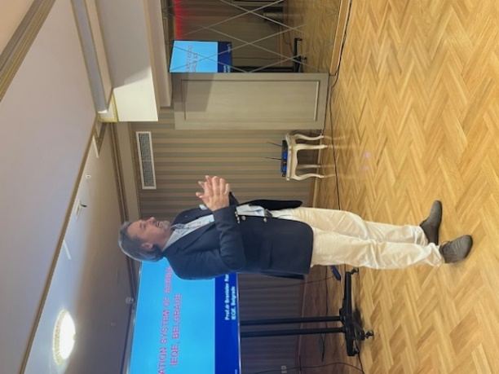
- PhD Branislav Ranđelović, director of the IEQE, introduced the Serbian educational system from an early age until graduation from secondary school. Institute for Education Quality and Evaluation carries out professional tasks in monitoring and evaluating the extent to which educational goals are achieved, including achievement standards by levels and types of education. The Institute conducts these professional activities through four organizational units. The Institute's centers conduct various essential functions. Center for Institutional Quality Assurance focuses on self-evaluation, external evaluation, and teacher training. Its key tasks include developing educational standards, creating quality standards for institutions, participating in external evaluations, creating methodologies and tools for institutional self-evaluation and external evaluation, and implementing training programs for teachers in self-evaluation, pedagogical value assessment, and student progress monitoring. Standards are defined across key areas, including student achievement, learning conditions, curriculum alignment, and continuous professional development for teachers to ensure educational accountability in alignment with national goals. The Examination Center manages exam strategy, design, and implementation of national exams and develops training programs to improve exam preparation and administration. The Center for International, National Examinations and Developmental Research performs evaluations, conducts research to enhance educational quality, and provides analytical reports to the Ministry. The Educational Technology Center focuses on integrating digital education, developing tools, and providing resources and support for digital competencies, self-evaluation, and quality assurance in educational institutions. Branislav talked about institutions within the education system such as the Institute for Improvement of Education, the Institute for Education Quality and Evaluation, the Qualification Agency, and the Ministry of Education. The important partnerships with organizations outside of Serbia, such as OECD, IEA, CIDREE, and SICI, were also highlighted.

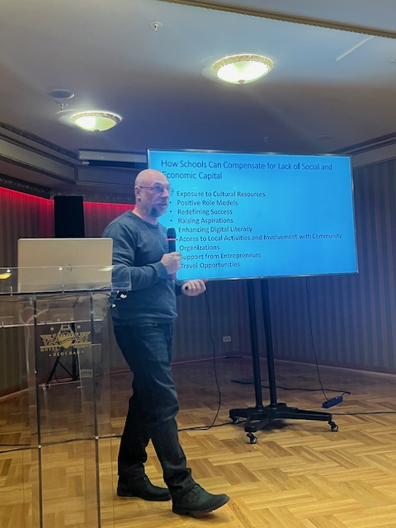
- PhD Elizabeta Karalić and Danijela Đukić presented a detailed overview of the upcoming week’s activities, providing a comprehensive summary that included scheduled events, key objectives, and valuable information. They aimed to enhance participant engagement and understanding throughout each session. The Serbian team examined the Tessimeter with school staff, parents, adolescents, and students across 6 different schools. Schools had two weeks to complete the questionnaires. The selection encompassed a diverse range of schools within the Serbian education system, underscoring the project’s commitment to inclusivity and relevance across all educational contexts.
- PhD Dragan Stanojević (Department of Sociology, Faculty of Philosophy, University of Belgrade) talked about inclusion which aims to enhance equality and reduce inequality in education by providing opportunities for all students. Inclusion in education aims to promote equality by ensuring that all students have access to the same opportunities and resources, regardless of their background. Addressing social inequalities is key, as these inequalities reflect unequal access to valuable material and nonmaterial resources, resulting in varying life opportunities, conditions, and outcomes for different individuals and social groups. Inclusion also involves creating supportive environments that recognize and address diverse needs, enabling every student to reach their full potential. The presentation focused on social inequalities from a sociological perspective, highlighting the need to address disparities in access and support while promoting inclusive practices. Social inequalities in Serbia impact education by limiting access to resources and creating barriers for students, leading to differences in academic success and educational attainment. Schools work to bridge these gaps with cultural resources, role models, digital literacy, and community involvement. Gender stereotypes, often shaped by socialization, restrict student interests. To address this, Serbian schools promote diversity and equality with zero-tolerance discrimination policies, equal standards, and support for excluded students. Inclusive practices, staff training, and expert support help create an environment where all students can thrive.

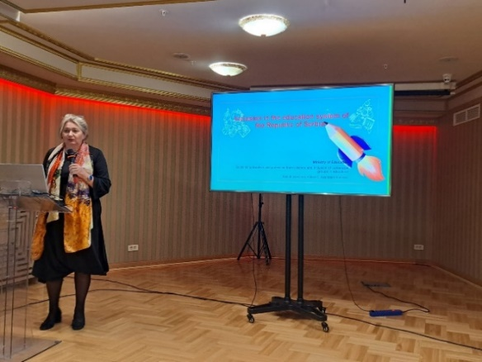
- PhD Snežana Vuković (Ministry of Education RS) presented inclusion and education system policies in the Republic of Serbia. Before 2009, Serbia’s education system separated Roma children and those with disabilities into specialized schools, with children with severe disabilities largely excluded and placed in social welfare institutions. This changed in 2009 with the introduction of Inclusive Education through the Law on the Foundations of the Education System, which mandated the enrolment of all children in the regular school system ensuring access for all children to regular schooling and tailored support for students with disabilities, learning challenges and other disadvantages. From 2009 to 2012, school-level teams, individual education plans, and intersectoral support services were established, integrating health, education, and social welfare. Progress accelerated from 2017 to 2024, focusing on capacity-building and support mechanisms across municipalities and regions. Resource centers were created to assist schools with inclusive practices, while the Ministry of Education implemented mentoring programs, utilizing external advisors to support schools. Model schools for inclusive education and Teachers' Communities of Practice emerged, fostering peer-to-peer learning and the sharing of best practices. Monitoring systems, including the Education Management Information System (EMIS) and National Reports on Inclusive Education, have been instrumental in tracking progress and assessing the impact of inclusive policies.

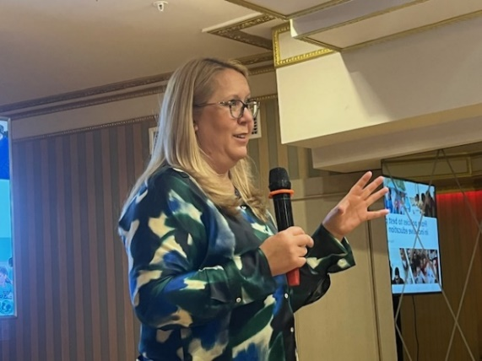
- Tanja Ranković (UNICEF) covered topics from policies to best practices, and explored inclusive education in Serbia, highlighting key strategies and initiatives aimed at ensuring equal opportunities for all students. UNICEF in Serbia supports national institutions to ensure every child’s right to quality education, with a focus on children from low socio-economic backgrounds, those with disabilities, national minorities, and refugee and migrant children. Partnering with the Ministry of Education, UNICEF helps strengthen the legal framework, build institutional capacity, and develop inclusive education models. Priorities include enhancing access, quality, and inclusivity across preschool, primary and secondary education. Tanja Rankovic emphasized that UNICEF Serbia supports education reform aimed at quality inclusive education, which includes preventing dropouts, combating discrimination, and data management. UNICEF Serbia has also provided technical assistance for developing the new Education Strategy 2030, based on global knowledge and locally generated data and research.
- Elizabeta Karalić provided details for visiting schools planned for Wednesday and Thursday. The attendees were divided into three groups, and each was assigned a different school to visit on Wednesday and Thursday with representatives from the host country. Six schools were designated for visits: two primary schools, two technical schools, one gymnasium, and one special school.
- The guided tour in Belgrade city center provided an enriching experience as participants walked with a tourist guide through the city's core. This tour included visits to key institutions such as the Serbian Parliament and the Belgrade City Hall. Visitors explored cultural-historical monuments like Kalemegdan Fortress, St. Sava Temple, and Republic Square, allowing them to learn about the city's rich heritage while enjoying its vibrant atmosphere.

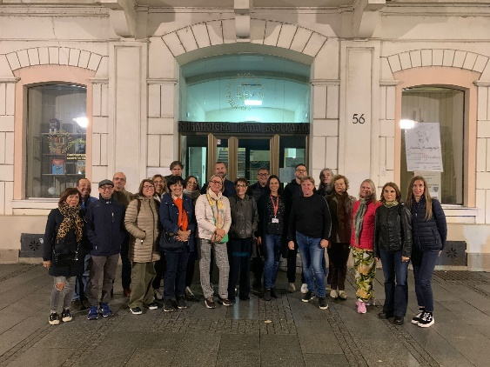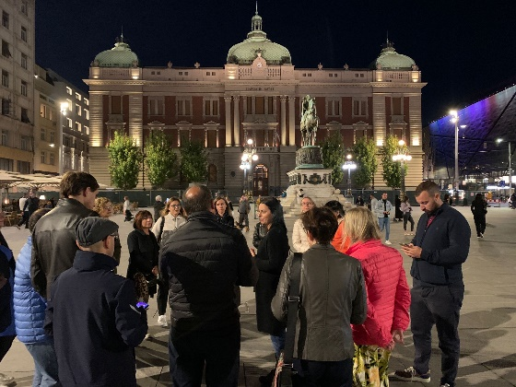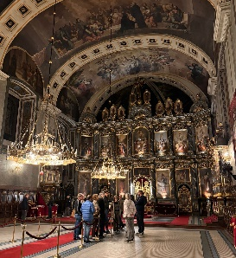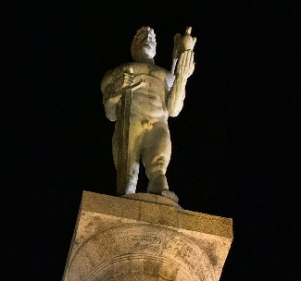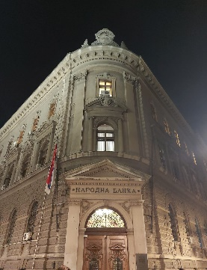

Wednesday October 16th, 2024

- Visit the three schools in Belgrade that tested the tool “Tessimeter” (Technical school “Drvo art”; Primary school “Anton Skala” and Primary school “Kralj Petar Prvi”). The groups attended presentations at the school and engaged in discussions with school staff, parents, and students regarding the completed questionnaire.
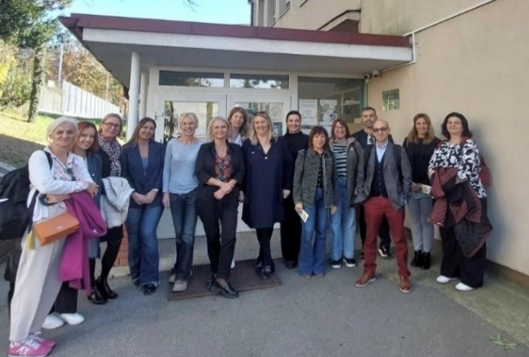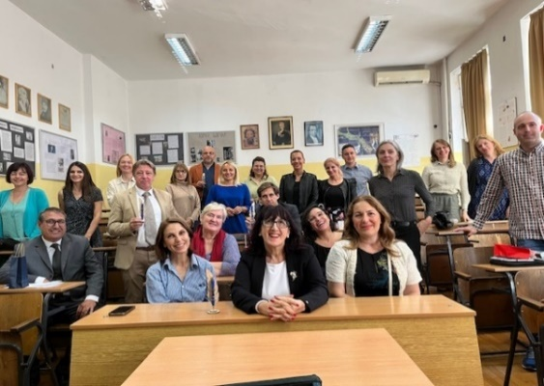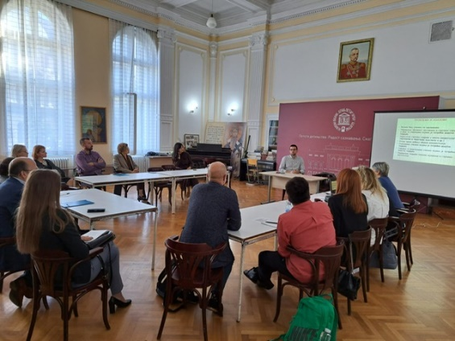

- STESSIE expert Ana María Esteve López covered the topic of Teacher training programs and Gender equity in the Valencian community. She comprehensively introduced CEFIRE and Coeducación to the present participants and hosts. CEFIRE is a teacher training center that supplies resources to school staff and consists of strategic lines (Teaching & learning; Emotional well-being; Professional commitment and Direction and leadership), as well as priority lines (literacy skills, environmental sustainability, computational thinking, robotics, AI and internationalization). There are two types of CEFIRE, that is specific (which includes inclusion, innovation, resources, leadership, and vet) and general (which is based on geographical lines). Coeducación gender equity implies equity and equal opportunities for all. A co-educational school provides an environment where barriers and inequalities stemming from societal sexism and other discriminatory mechanisms based on sex, gender identity, ethnicity, sexual orientation, and social background are actively removed. This creates a space where students can freely develop their identities in conditions of true equity. This is also promoted through Gender Equity Campaigns and Specific training on gender equity.

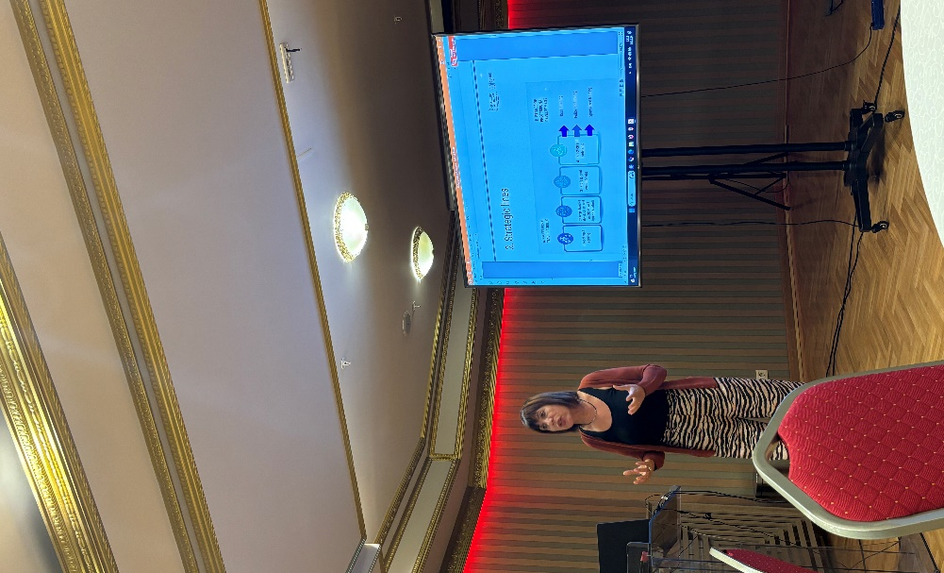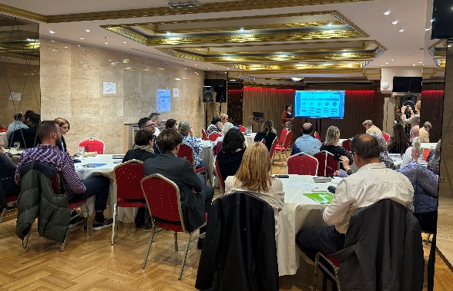

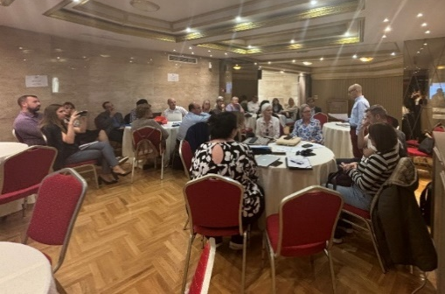
- Brainstorm in groups about TESSIE questionnaire: The topics about “Tessimeter” and experiences of schools in Serbia (Technical school “Drvo art”; Primary school “Anton Skala” and Primary school “Kralj Petar Prvi”):

During the group brainstorming session on the TESSIE questionnaire, participants discussed several topics related to the “Tessimeter” and shared their experiences from schools in Serbia. The discussion centered around the strengths and weaknesses of the questionnaire, with participants highlighting various benefits, such as its thoroughness and relevance to the educational context. However, they also identified several challenges faced by school staff during the completion of the questionnaire. These included language-related ambiguities, overly long and complex questions, and instances where multiple issues were addressed within a single question, making it difficult to respond clearly. Overall, the participants provided valuable insights, with many agreeing that while the questionnaire is useful, certain adjustments could enhance its clarity and effectiveness.

- Dinner was organized by the host in the restaurant “Proleće” in Belgrade’s city center.

Thursday October 17th, 2024

- Visit the three schools in Belgrade that tested the tool “Tessimeter” (Railway - technical school; Primary school “Vladislav Ribnikar” and First Belgrade Gymnasium). The groups attended presentations at the school and engaged in discussions with school staff, parents, and students regarding the completed questionnaire.

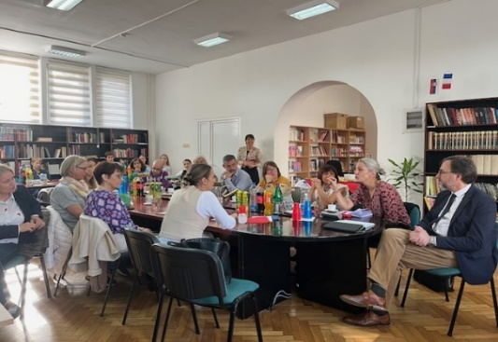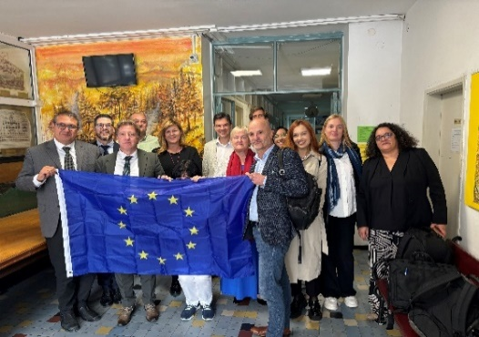
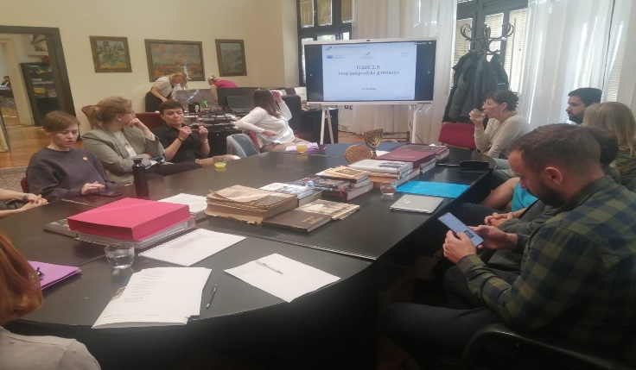

- STESSIE expert Wilma Brings had a presentation on Special Needs Education in North Rhine-Westphalia (NRW) where she highlighted the importance of multi-professional teams and addressed challenges. The Quality Analysis Framework, including the Inspection Framework and Lesson Observation Sheet, evaluates inclusive practices in schools. An example from Düsseldorf showcased a structured approach, effectively integrating inclusive practices within the educational community. Schools in NRW implement a comprehensive approach to inclusive education, offering tailored curricula, smaller class sizes, and individualized support to meet each student’s unique needs. With services like speech therapy, occupational therapy, and counseling, students receive a range of support for academic, social, and emotional growth. Teachers collaborate with multi-professional teams—including special education teachers, psychologists, and social workers—to develop Individual Education Plans (IEPs) and facilitate interdisciplinary support. Although facing some challenges such as insufficient funding or lack of training, team teaching, career counseling, and transition planning help students navigate their educational paths, while accessible infrastructure and continuous quality analysis ensure inclusive practices across general and special education settings.

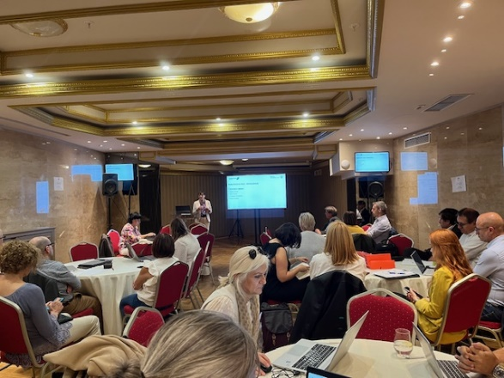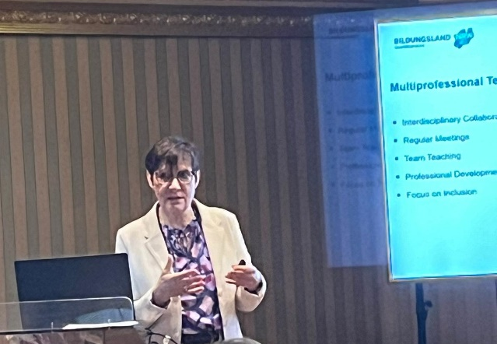

- Brainstorming in groups about TESSIE questionnaire: The topics about “Tessimeter” and experiences of schools in Serbia (Railway - technical school; Primary school “Vladislav Ribnikar” and First Belgrade Gymnasium).

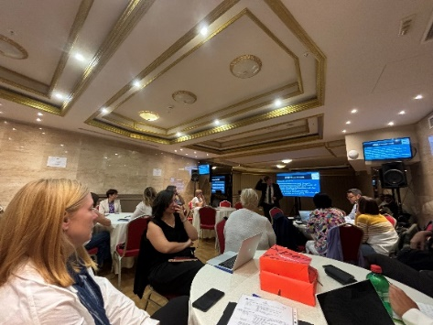
- Preparation for the Multiplier Event was led by Erik De Bou, who provided a comprehensive overview of the anticipated outcomes associated with the TESSIE project. He outlined the expected results, explaining how these align with the project’s objectives to enhance user engagement and functionality. Additionally, Erik presented the intended steps for the completion and further refinement of the tool. This preparation aimed to equip attendees with a clear understanding of TESSIE’s potential impact and the collaborative efforts driving its development.

- Official Dinner was organized by the host in the restaurant “Caruso” in Belgrade’s city center.

Friday October 18th, 2024

The Multiplier event was scheduled for Friday, October 18th, 2024, and took place in the Moskva hall of the Hotel Moskva, allowing those who could not attend in person to join online through a link.

- Danijela Đukić and Elizabeta Karalić discussed self-evaluation practices within educational institutions across Serbia, examining key elements like school programs, achievements aligned with educational standards and the involvement of parents and legal guardians in diverse educational activities. They also touched upon Serbia’s quality assurance framework. Additionally, they presented insights from the Training Meeting outcomes, including the testing of the "Tessimeter" tool in Serbia, the number of participants who completed the accompanying questionnaire, and feedback gathered on the tool’s effectiveness.

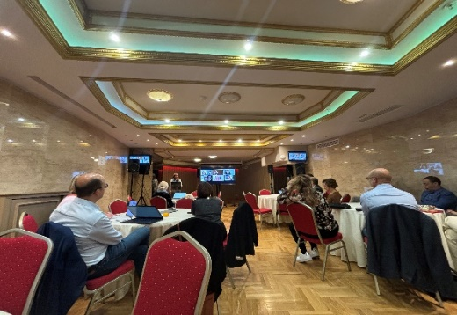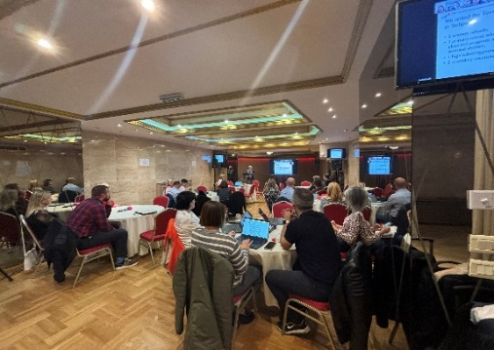

- International partners, as well as present Erik De Bou and Elizabeta Karalić concluded the conference with a Summary of STESSIE & Results of TESSIE 2.0, shared information about the upcoming steps, and discussed important aspects of the training that took place in Serbia. Additionally, they highlighted the essential role of continued international cooperation in achieving long-term objectives and sustaining the positive outcomes of the training.

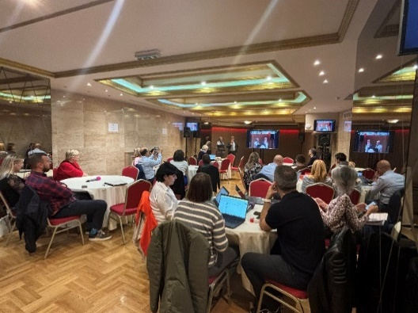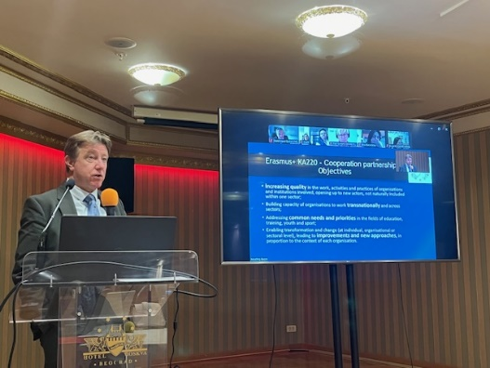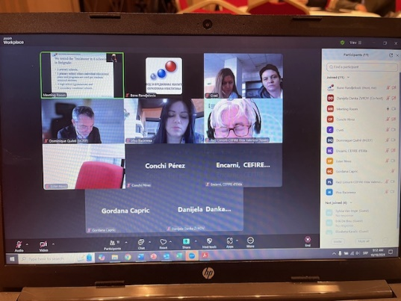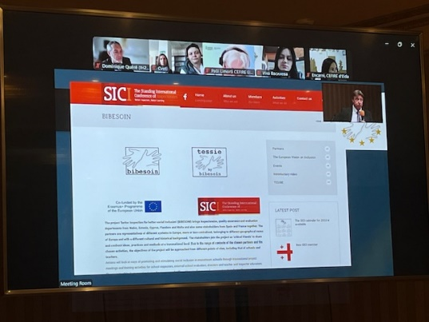

Keynotes and comments:

- Purpose and Utility:

The questionnaire is a valuable tool for the school's internal self-reflection, helping identify areas for improvement based on input from students, school staff, and parents.

- Teachers’ Feedback:
Teachers noted the need for a guidebook, some kind of manual, to assist school staff in using the tool effectively, suggesting that clearer guidance could enhance the tool's utility for newcomers.

- Effectiveness of Questions:
Specific TESSIE questions prompted school staff to rethink certain issues, indicating that the questionnaire successfully raised awareness about key topics. Certain questions are not relevant to the Serbian education system, for example, the question related to the nutrition that students have in schools.

- Language Accessibility:
While the language was clear for school staff, parents found it more challenging. This suggests that simplifying language or providing additional explanations could improve parental engagement.

- Student Engagement:
Students found the questions easy to understand and appreciated the opportunity to share their perspectives, recognizing the questionnaire as a way for the school to consider their viewpoints.

